
 | FI 1: Display Chart of Accounts
Exercise Display a chart of accounts. Time 10 min
Task Use the SAP Easy Access Menu to review a listing of the General Ledger (G/L) accounts that are part of your chart of accounts. For each G/L account, the chart of accounts contains the account number, the account name, and additional technical information.
Name (Position) Shuyuan Chen (Chief Accountant)
A chart of accounts may be shared by many company codes. Each company code must be assigned a chart of accounts. Once a chart of accounts is assigned to a company code, it becomes the operative chart of accounts for that company code and it is used to capture information for both Financial Accounting (FI) and Cost Accounting (CO).  Other possible charts of accounts may be required to capture additional information to support international business accounting purposes including:  - Country-specific charts of accounts - This is structured in accordance with legal requirements of a specific country.  - Group chart of accounts - This is structured in accordance with requirements pertaining to consolidated financial statements. |  | Chart of accounts  Other possible charts of accounts
In order to display a chart of accounts, follow the SAP Easy Access menu path:  Accounting ► Financial Accounting► General Ledger ► Information System ► General Ledger Reports (New) ► Master Data ► Chart of Accounts |  | Menu path
In the Chart of accounts field, use the F4 key to find and select the global GBI chart of accounts (GL00) and enter 1 for Charts of accts not assigned. |  | GL00  1
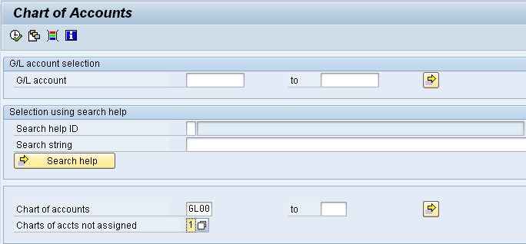
Then, click on (Execute).
Record information on your chart of accounts in the table below:
G/L Account Number | G/L Account Name
100000
200100
300000
310000
600000
700000
720300
740300
741500
770000

Click on the exit icon twice to return to the SAP Easy Access Screen.

 | FI 2: Display Chart of Accounts II
Exercise Use the SAP Easy Access Menu to display a chart of accounts. Time 5 min
Task Review a listing of the General Ledger (G/L) accounts that are part of your chart of accounts and that have been made operative for your company code. Each G/L account being used by a company code has both chart of account and company code specific information. In this way, a chart of accounts may be used by several company codes with each having their own unique information and settings.
Name (Position) Shuyuan Chen (Chief Accountant)
To do this, follow the menu path:  Accounting ►Financial Accounting ► General Ledger ► Information System ► General Ledger Reports (New) ► Master data ► G/L Account List |  | Menu path
Enter GL00 for Chart of accounts.
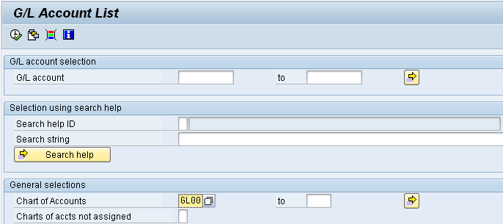
Then click on (Execute).
How does this information differ from the information in Exercise FI 1? What are the company codes this chart of accounts is assigned to?

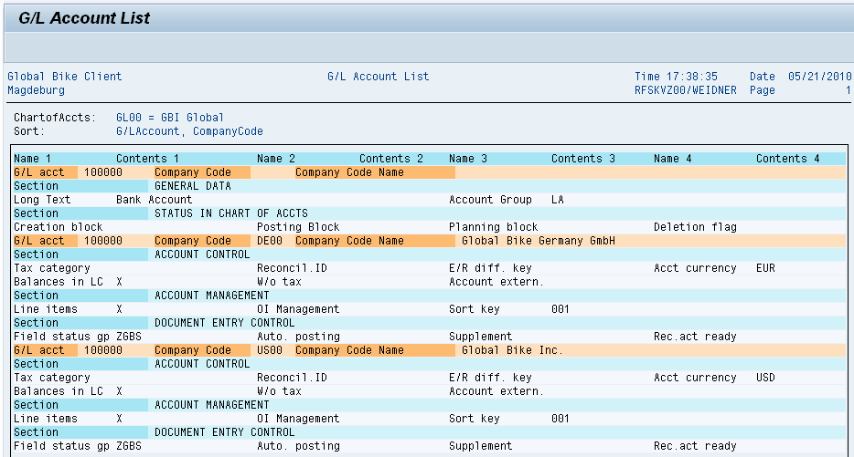
Click on the exit icon twice to return to the SAP Easy Access Screen.

 | FI 3: Display General Ledger Account
Exercise Display a General Ledger account. Time 10 min
Task Use the SAP Easy Access Menu to display a General Ledger account in your chart of accounts (alternative bank account). Businesses commonly maintain several bank accounts (e.g. payroll, general checking and money market) that are listed on their balance sheet.
Name (Position) Shuyuan Chen (Chief Accountant)
To do this, follow the menu path:  Accounting ► Financial Accounting ► General Ledger ► Master Records ► G/L Accounts ►Individual processing ► Centrally |  | Menu path
In the G/L Account field, use the F4 key to open the search window (make sure to select the G/L account description in chart of accounts tab). Enter Alternate* for G/L long text and write GL00 in the Chart of Accounts field. |  | Alternate*  GL00
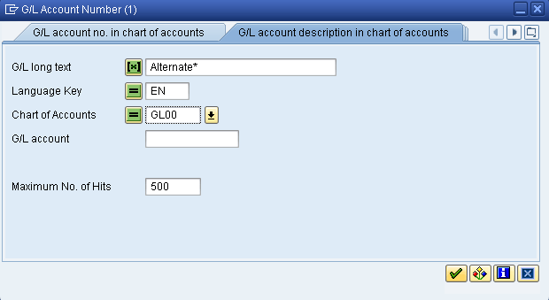
Then, press Enter or click on . On the result screen, double-click on the Alternate Bank Account row to select G/L account 101000. |  | 101000
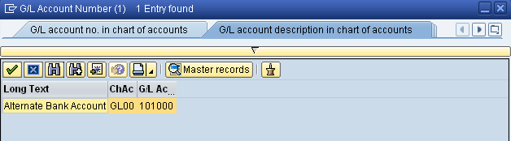
After the account number (101000) is populated into the G/L Account field, find and select Company Code US00. Then, press on the button to display the G/L account data. |  | US00
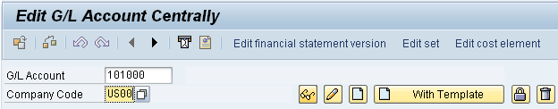
What Account Group is this G/L account assigned to?

Is this account a Profit and Loss Statement account or a Balance Sheet account?

What is the account currency?

Repeat the same procedure for the same G/L account, but for the German GBI Company Code (DE00). |  | DE00
What differences did you find?

You may look at other G/L account details if you would like.
Click on the exit icon to return to the SAP Easy Access Screen.

 | FI 4: Post Transfer of Funds to Alternate Bank Account
Exercise Transfer funds to Alternate Bank Account. Time 10 min
Task Use the SAP Easy Access Menu to generate a journal entry for the US GBI company to transfer funds from your current bank account to your alternate bank account.
Name (Position) Clayton Bartolome (Fixed Assets Accountant)
To do this, follow the menu path:  Accounting ►Financial Accounting ► General Ledger ► Posting ►  Enter G/L Account Document |  | Menu path
If Company Code US00 is not displayed use the Menu Entry Edit ► Change company code (F7) to select your US GBI company. In the Document Date field, use F4 and Enter to select today’s date and choose USD as Currency. As Reference, enter your three-digit number (###) and as Doc. Header Text Transfer of Funds. |  | US00  today’s date  USD  ###  Transfer of Funds
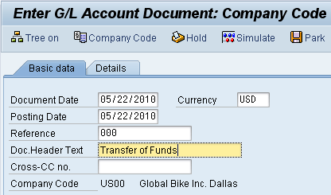
On the first line, enter 101000 (Alternate Bank Account) as G/L acct, choose Debit as D/C and enter 5000 as Amount in doc.curr. |  | 101000  Debit  5000
On the second line, enter 100000 (Bank Account) as G/L acct, choose Credit as D/C and enter 5000 as Amount in doc.curr. |  | 100000  Credit  5000
Then click on (Enter).
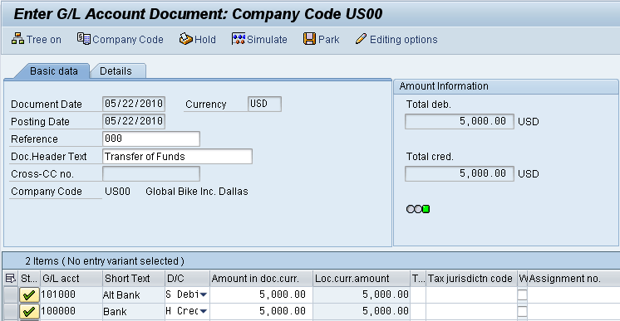
Use the button to see if the postings are correct.
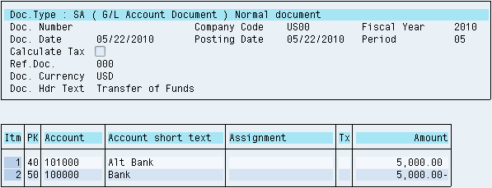
Do Debits equal Credits?
What kind of accounts make up this transaction?
What does PK stand for on the simulate screen?
Click on (Back) once and accept any warning messages with Enter.
Then, click on (Post). The system will create a unique G/L account document number. |  | G/L account document
Click on the exit icon and acknowledge the warning message by choosing YES – there will be no data lost. This brings you back to the SAP Easy Access menu. |  | YES

 | FI 5: Display G/L Account Document
Exercise Display a G/L account document. Time 10 min
Task Use the SAP Easy Access Menu to display the G/L account document you have just created.
Name (Position) Clayton Bartolome (Fixed Assets Accountant)
To display a G/L account document, follow the menu path:  Accounting ► Financial Accounting ► General Ledger ► Document ► Display |  | Menu path
Your account document number should already be entered. If not, click on . Then, choose Company Code US00 and enter ### (your three-digit number) in the Reference number field. Then, click on to execute the search producing a Document List screen similar to the one shown below. |  | US00  ###
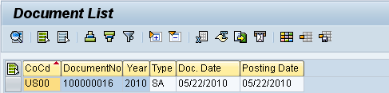
Double-click the document number to display the document. The system displays a similar screen to the simulate screen you saw just before your posted your document in the previous exercise.
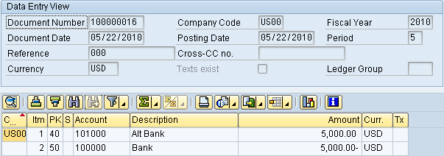
What do the Posting Keys (PK) 40 and 50 mean?
40
50
Click on the button to display the document header information. Who created the document and when?

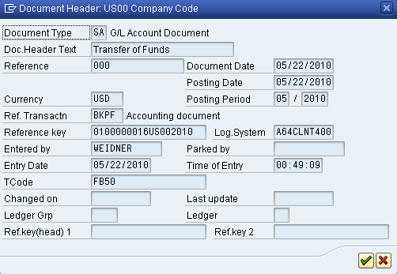
Press Enter to go back to the Display Document: Data Entry View screen.
Then, click on the exit icon to go back to the SAP Easy Access menu.

 | FI 6: Post Purchase of Office Supplies
Exercise Post a purchase of office supplies. Time 10 min
Task Use the SAP Easy Access Menu to generate a journal entry for your alternate bank account to purchase office supplies.
Name (Position) Clayton Bartolome (Fixed Assets Accountant)
The business scenario is that you need some office supplies immediately. You drive down to Office Supply Depot and buy $175 of supplies (paper, folders, and a software package) and pay for the purchase with a company check drawn on your alternate bank account. |  | Business Scenario
To do this, follow the menu path:  Accounting ► Financial Accounting ► General Ledger ► Posting ► Enter G/L Account Document |  | Menu path
In the Document Date field, use F4 and Enter to select today’s date and choose USD as Currency. As Reference, enter your three-digit number (###) and as Doc. Header Text Purchase of Supplies. If Company Code US00 is not displayed use the Menu Entry Edit ► Change company code (F7) to select your US GBI company. |  | today’s date  USD  ###  Purchase of Supplies  US00
On the first line, in the G/L acct field use the F4 help to find the account number for Supplies Expenses. To do so, select the G/L account description in chart of accounts tab enter Supplies* in the G/L long text. Then, press Enter. |  | Supplies*
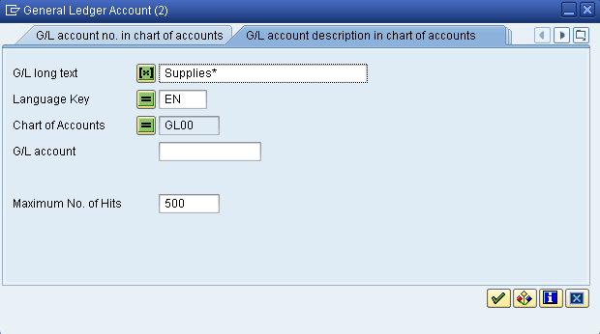
Then, double-click on the result row to select G/L account number 740000.  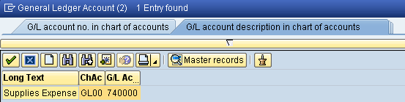 |  | 740000
Back on the first line, choose Debit as D/C and enter 80 as Amount in doc.curr. Then, scroll to the right until you see the Cost center column and enter NAIS1000 (Internal Services). |  | Debit  80  NAIS1000
On the second line, enter 740000 as G/L acct again, choose Debit as D/C and enter 95 as Amount in doc.curr. Then, scroll right until you see the Cost center column again and enter NAIT1000 (IT costs). |  | 740000  Debit  95  NAIT1000
On the third line, enter 101000 (Alternate Bank Account) as G/L acct, choose Credit as D/C and 175 as Amount in doc.curr. Then, click on (Enter). |  | 101000  Credit  175
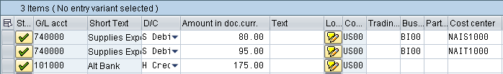
Use the button to see if the postings are correct.
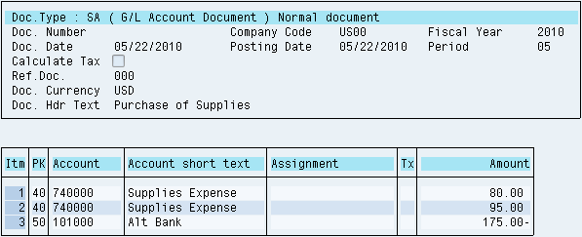
Then, click on (Post) and record the document number. |  | G/L account document
Click on and choose YES to return to the SAP Easy Access menu. |  | YES

 | FI 7: Display General Ledger Account Balances
Exercise Use the SAP Easy Access Menu to display G/L account balances. Time 10 min
Task Use the SAP Easy Access Menu to display and confirm by individual account number the activity and associated balances for several accounts in the general ledger of the US GBI company.
Name (Position) Clayton Bartolome (Fixed Assets Accountant)
To do this, follow the menu path:  Accounting ► Financial Accounting ► General Ledger ► Account ►  Display Balances (New) |  | Menu path
Enter 101000 as Account Number, US00 as Company Code and the current year as Fiscal Year. |  | 101000  US00  current year
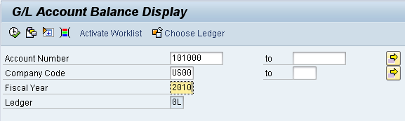
Then, click on (Execute). The system should display a table similar to the one shown below.
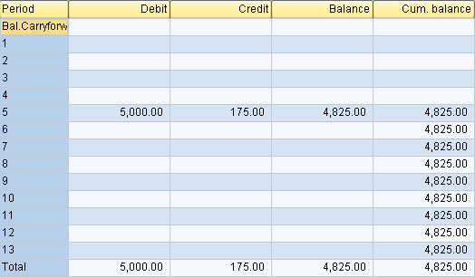
If your numbers are different, can you explain why?

Double-click on the debit amount of the current month. The system displays all documents that make up the total credit amount. Find your document number in the list.
Note: The screen shot below displays one document as the author has posted debits in one G/L account document only.
In your case, there might be multiple versions of the same posting. Remember that similar to a real company you are posting to the same G/L accounts together with your fellow students.
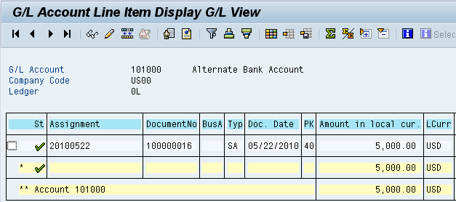
Click on the exit icon until you are back on the SAP Easy Access Screen.

 | FI 8: Change Financial Accounting Document
Exercise Change a financial accounting document. Time 10 min
Task Use the SAP Easy Access Menu to complete changes for a previously posted financial accounting document. It is important to note that some changes are permitted while others are fully restricted.
Name (Position) Clayton Bartolome (Fixed Assets Accountant)
To do this, follow the menu path:  Accounting ► Financial Accounting ► General Ledger ► Document ► Change |  | Menu path
First, select . On the selection screen, enter US00 as Company Code, the current year as Fiscal Year, and SA as Document Type. As Posting Date enter a range of dates that will include your document (saved in the FI 4 exercise). |  | US00  current year  SA
Then, click on (Execute).
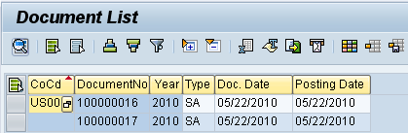
Double-click on the number of the document you wish to change.
In the Change Document: Data Entry View screen, double click on the first item.
What can you change?

Select (Display document header).
What can you change?

Change the Doc. Header Text to “Test for Change”. |  | Test for Change
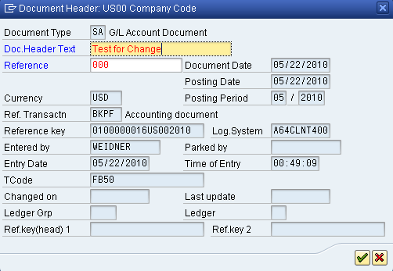
Click on (Continue). Then, click on to save.
Why can’t you change the amount of the line item?

Click on the exit icon until you are back on the SAP Easy Access Screen.

 | FI 9: Display Changes to Financial Accounting Documents
Exercise Display changes to financial accounting documents. Time 10 min
Task Use the SAP Menu to display and confirm the changes entered in the previous exercise.
Name (Position) Shuyuan Chen (Chief Accountant)
To do this, follow the menu path:  Accounting ► Financial Accounting ► General Ledger ► Document ► Display Changes |  | Menu path
The system should have already defaulted in Company Code US00, your doc. number, and the current year as Fiscal Year (if not, please do so). Then, press Enter. This should produce the following screen. |  | US00  document number  current year
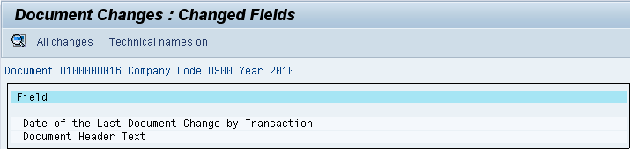
Then, click on .
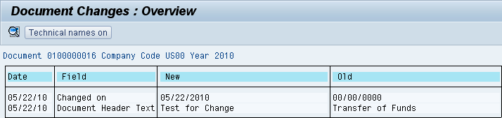
Highlight the “Document Header Text” line. Then click on (Choose).
Who made the changes and when were they made?

Press Enter. Then, click on to return to the SAP Easy Access Screen.

